Year Two’s Half Termly Newsletter - Autumn 2 2024

We are really excited about our learning journey together during this very busy and fun filled half term. As always, there will be lots of new learning taking place and we are all extremely excited about our Nativity performance, which is destined to be fab-u-lous!

Home Learning
In Year Two, we continue to prioritise reading. We ask that pupils read at least five times a week at home. We understand that it is not always possible for pupils to read with an adult every day so we also encourage independent reading. The children will have lots of opportunities to read and enjoy books throughout the week at school too. Pupils accessing the RWI phonics programme will continue to take home reading books from the scheme that are closely matched to ability. Children on the Accelerated Reader programme will bring home a book from our library and will change this once they have read the book and completed the quiz. Please encourage your child to put their book in the tray (by the computers) to be changed when you feel they have a full understanding of the text.

Pupils will also continue to be encouraged to access Times Table Rock Stars and take part in numerous battles throughout the course of the year. A strong times table knowledge builds an excellent foundation for mathematical understanding, so please do encourage your child to access TT Rock Stars daily. Children in Y2 are expected to be able to answer questions about the 2, 5- and 10-times tables. Numbots can also be accessed to ensure children are confident in their number bond knowledge.

This half term’s home learning menu is attached, it provides your child with lots of different ideas to further their learning at home. We encourage pupils to complete at least one activity from the menu per half term. We will dedicate time at the end of the half term to share and celebrate any work completed from the menus. We were delighted with the enthusiasm for these last half term for Science. We are now excited to see what our young Historians will produce. .

This half term, we are moving over to a new spelling scheme called 'Ready Steady Spell', which we know has great potential to help children develop excellent spelling skills. In these first 2-3 weeks, we won't be sending home lists of words for children to learn at home as we will be preparing to move over from the old to new spelling scheme. When we are ready to roll out the new scheme, we will send home more information about how you can support children with their spelling at home, as well as new lists of spellings for the children to learn at home for their weekly tests.

Housekeeping
- Please ensure that your child’s book bag comes to school each day, with their reading book and home Learning Journal. Polite reminder for one small, preferably named keyring on these please.
- As requested on the school newsletter, we ask that any water bottles and snack pots brought in aren’t too big. The children have to keep these in shared trays, which are carried to the playground at breaktimes and larger items make this tricky.
- PE will continue to be on a Thursday afternoon.

Thank you as always for your continued support, please do get in touch if you have any
questions or concerns. Kind regards,

Mrs Hughes, Mrs Rogers and Mr Dawn

Jesus said, ‘Come follow me, live your lives the way God wants you to.’
Year 2 Curriculum Map

Maths  We will finish subtracting with renaming. We will then learn about multiplications as equal groups and then learn the 2x and 5x tables so we can recall the multiplication facts quickly. We will continue using Timetable Rock Stars to develop speedy recall of number facts.  Our class targets will be to recall number bonds to 10, 20 and 100 and to use these to help us solve mathematical problems. | English/RWI  This term we will be studying the captivating and enchanting picture book ‘The Night Gardener’. The children will be immersing themselves in the text and analysing the language features used by the author. The children will then plan and write their own setting narrative and diary.  RWI session will continue for a number of pupils, whilst the rest of the class have a grammar of guided reading lesson. | Science  This half term we will learn about living things and their environment. We will learn how to classify living things and will be studying different habitats. We will also be learning about the food chain and will explore key vocabulary such as producers and consumers.
Art  We will be looking at colour and shape in art thi half term. Following on from our art day with Mr Corcoran last half term, we will continue to develop our use of colour, tints, shades and geometric prints. With a focus on the artist Paul Klee. | History  In History, we will consider the growth of some of the first civilisations. We will learn about how the ancient Egyptians were able to farm, the importance of the River Nile and findings of archaeologists about life in ancient Egypt.  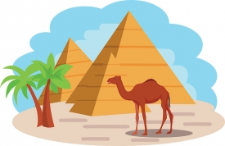 | RE  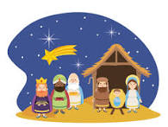  We will be learning about Christmas. We will consider and discuss why the birth of Jesus is such good news. We will reflect on the impact of this event both in the past and present day. We will learn about Christian beliefs and why we, as Christians, believe this news is so important and how it has impacted our lives.
P.E.  Dance: Pirates  This half term we will create and develop our own choreography for a dance entitled ‘Pirates’. We will study different techniques and work collaboratively to create a series of movements that complement our chosen piece of music. | PHSE: HeartSmart  ‘Too Much Selfie isn’t Healthy’  We will explore the concept of self-awareness and how we act with and around others. We will celebrate similarities and differences within our community and wider world. | D&T  We will be joined by Mrs O’Donnell this half term to design and build our own cars.

Year 2 History Home Learning Menu
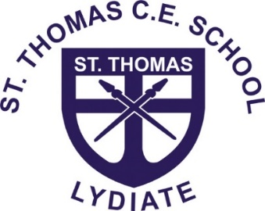
Autumn 2

Get Creative  Can you be creative? Choose to learn about the River Nile, Pharaohs or Pyramids. Can you create some quality artwork or impressive 3d models to represent your learning? Take your time and write information to explain your work to others as if it is displayed in a museum or art gallery. | Oh, the places you’ll go!  Can you visit the World Museum in Liverpool and journey through time while looking at the Ancient Egypt display?  “Join us on a 5,000-year journey as we uncover the mysteries of ancient Egypt. Whether it’s exploring our mummy room, learning about hieroglyphs or reading spells from the Book of the Dead, discover what life was like in the ancient world.”
Time to Teach  Can you deliver a lesson to a member of your family all about hieroglyphics? Can you explain how and why they were used? Can you teach them how to write their name or some interesting words using a hieroglyphic alphabet? Can you set up a teaching display or working wall at home that you can continue adding to?  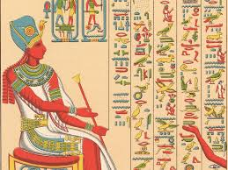 | Reason to Research  Can you do some research about Egypt? Can you locate it on a world map? What continent is it in? What is it famous for? What is the weather like? What traditional foods are eaten there? Try creating a report or detailed fact file showing key information?  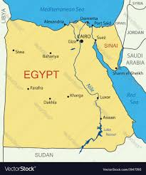
Ready to Report  Can you research the weather in Egypt then prepare and deliver a weather report? How is the climate different and the same to ours in the United Kingdom? Can you explain why this is? Showcase this in any way you prefer. | Have it your own way!  Or you can do it your own way! Explore this topic in any way you choose. Have fun and enjoy 😊

